**Lab 7: Database Implementation**

1. Create a new database named Shopping.

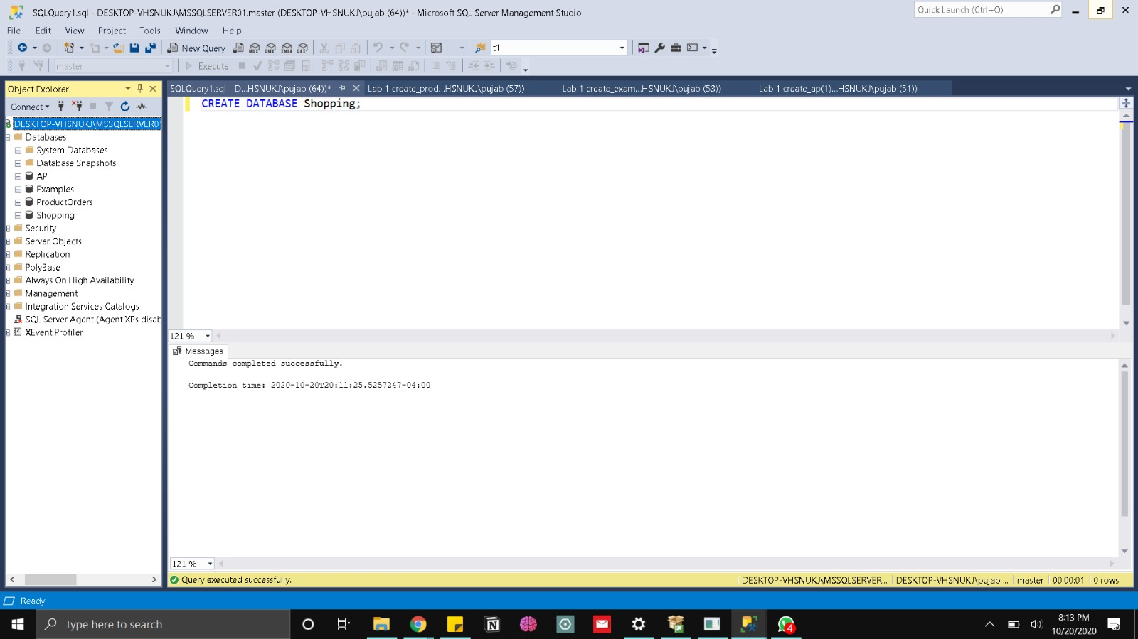

2. (1) Describe the relationship type shown in figure (one-to-one, one-to-many or many-to-many).

The relationship between the tables Customers and Products is of the type many-to-many. The linking table for these two tables is the CustomerGroups table. Regarding every customer, each customer can buy multiple products and as for every product, each product can be bought by many customers.

(2) Write the CREATE TABLE statements needed to implement the following design in the Shopping database. Include foreign key constraints. Define CustomerID and ProductID as identity columns. Decide which columns should allow null values, if any, and explain your decision. Define the ProductCost column with a default of zero and a check constraint to allow only positive values.

USE Shopping;

CREATE TABLE Customers

(CustomerID int NOT NULL IDENTITY PRIMARY KEY,

FirstName varchar(50) NOT NULL,

LastName varchar(50) NOT NULL,

Phone varchar(50) NULL);

CREATE TABLE Products

(ProductID int NOT NULL IDENTITY PRIMARY KEY,

ProductName varchar(50) NOT NULL,

ProductCost money NOT NULL DEFAULT 0 CHECK (ProductCost >= 0));

CREATE Table CustomerGroups

(CustomerID int REFERENCES Customers(CustomerID),

ProductID int REFERENCES Products(ProductID));

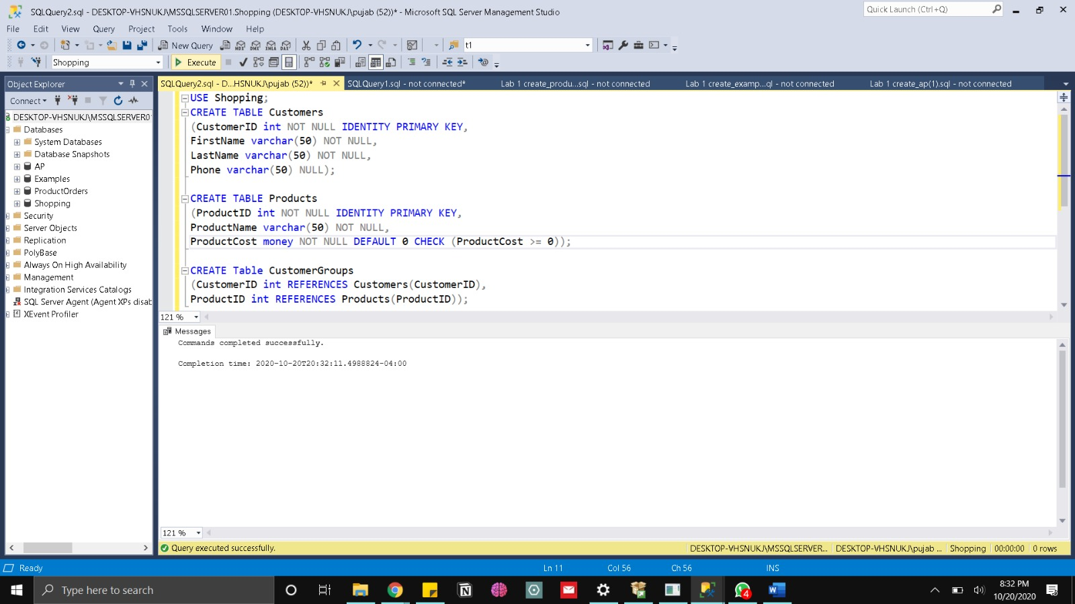

3. Write the CREATE INDEX statements to create a clustered index on the ProductID column and a nonclustered index on the CustomerID column of the CustomerGroups table.

USE Shopping;

CREATE CLUSTERED INDEX IX_CustomerGroups_ProductID

ON CustomerGroups(ProductID)

CREATE INDEX IX_CustomerGroups_CustomerID

ON CustomerGroups(CustomerID);

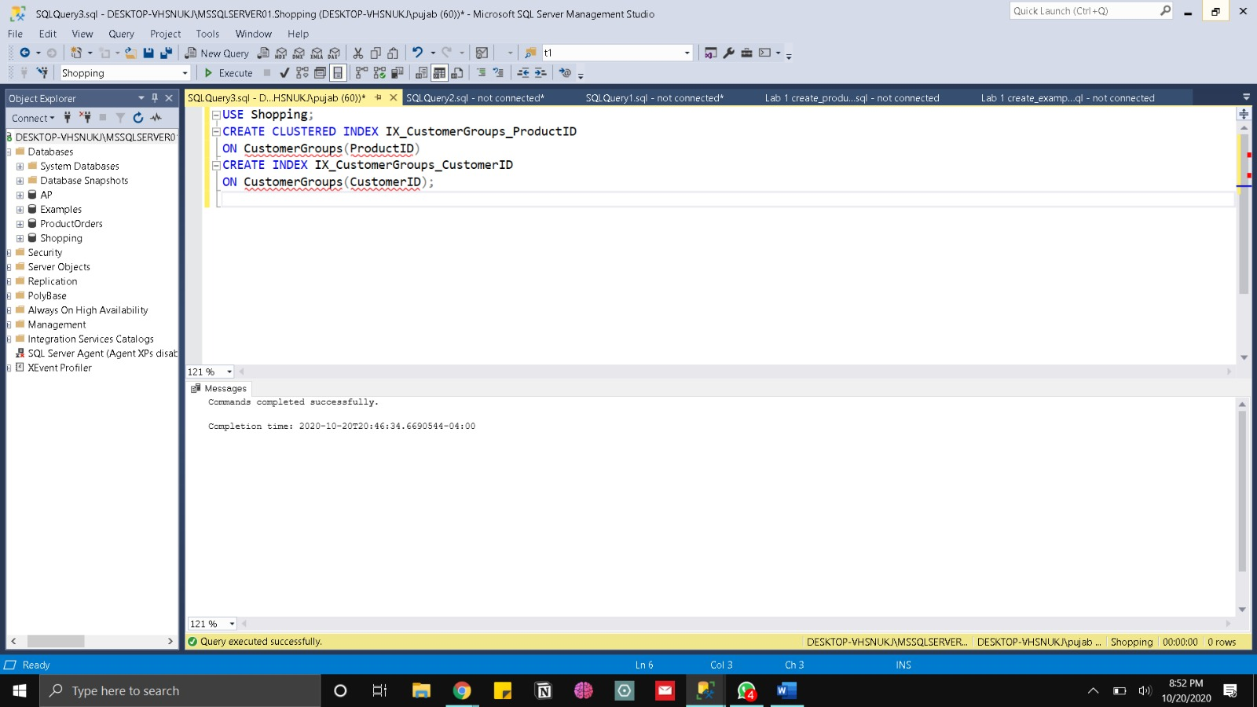

4. Write an ALTER TABLE statement that adds a new column, BillsPaid, to the Customers table. Use the bit data type, disallow null values, and assign a default Boolean value of False.

USE Shopping;

ALTER TABLE Customers

ADD BillsPaid bit NOT NULL DEFAULT 0;

5. Write an ALTER TABLE statement that adds two new check constraints to the Invoices table (in AP database) of the AP database. The first should allow (1) PaymentDate to be null only if PaymentTotal is zero and (2) PaymentDate to be not null only if PaymentTotal is greater than zero. The second constraint should prevent the sum of PaymentTotal and CreditTotal from being greater than InvoiceTotal.

USE AP;

ALTER TABLE Invoices

ADD CHECK ((PaymentDate IS NULL AND PaymentTotal = 0) OR

(PaymentDate IS NOT NULL AND Payment >0)), 2

CHECK ((PaymentTotal + CreditTotal) <= InvoiceTotal);

2702

6. Delete the CustomerGroups table from the Shopping database. Then, write a CREATE TABLE statement that recreates the table, this time with a unique constraint that prevents a customer from being a customer-group member buying same product twice.

USE Shopping;

DROP TABLE CustomerGroups;

CREATE Table CustomerGroups

(CustomerID int REFERENCES Customers(CustomerID),

ProductID int REFERENCES Products(ProductID),

UNIQUE(CustomerID, ProductID));

7. Use the Management Studio to create a new database called Shopping2 using the default settings. (Do not use SQL query to do this).

